Number of customers attracted
Measure Values

Period: from 1/1/2021 to 12/31/2021
Unit: items | Target Value: 35 | Target Date: 1/1/2023

Measures Achievement of Objectives
Increase the number of customers
Attract customers

Is KPI for Activities
A2.1 Attract customers

Values
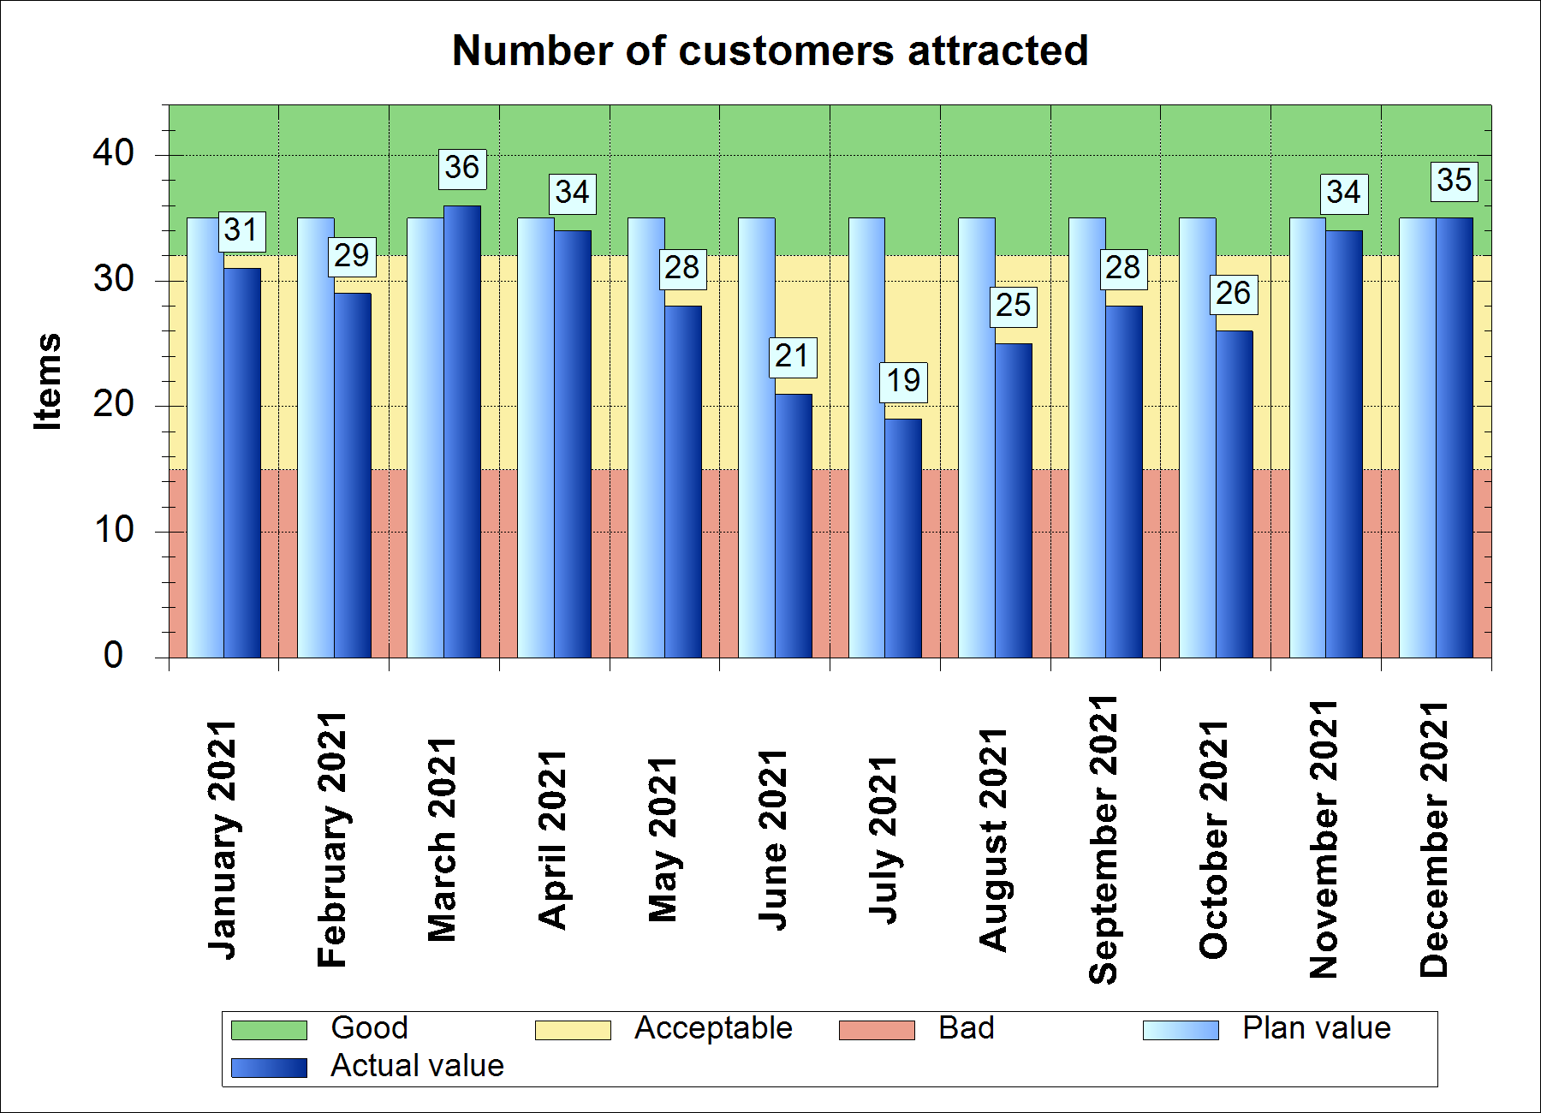

Status | Period | Plan Value | Actual Value | Indicator
 | January 2021 | 35 | 31
 | February 2021 | 35 | 29
 | March 2021 | 35 | 36
 | April 2021 | 35 | 34
 | May 2021 | 35 | 28
 | June 2021 | 35 | 21
 | July 2021 | 35 | 19
 | August 2021 | 35 | 25
 | September 2021 | 35 | 28
 | October 2021 | 35 | 26
 | November 2021 | 35 | 34
 | December 2021 | 35 | 35

