Process Simulation
Report

Process
Name | A4.2.5 Perform start-up works
Avg Duration | 13d.13:19:12
Avg Cost | 4.52 TEUR

Resources Used

Work Resources
# | Name | Shift | Hourly Rate |  | Avg Usage Time | Avg Cost,  TEUR
1. | Accountant | Shift 1 | 100.0000 | EUR
2. | Computer | 24-hour shift | 40.0000 | EUR
3. | Customer | Shift 1 | 0.0000 | EUR
4. | Director of Operations | Shift 1 | 300.0000 | EUR
5. | Instrument | 24-hour shift | 35.0000 | EUR
6. | Project Manager | Shift 1 | 180.0000 | EUR
7. | Technician | Shift 1 | 100.0000 | EUR
 | Sum |  |  |  |  | 4.5

Material Resources
# | Name | Price |  | Avg Quantity Consumed |  | Avg Cost,  TEUR
1. | A4 sheet | 0.3000 | EUR | 10.16 | items
2. | Printer (printing of one sheet) | 2.0000 | EUR | 9.88 | items
 | Sum |  |  |  |  | 0.02

Fixed Costs
# | Name | Cost Rate |  | Avg Sum,  TEUR
1. | Freight transport | 45,000.0000 | EUR Per month
 | Sum |  |  | 3.37

Avg Times and Costs of Subprocesses
# | Process | Processing Time | Wait Time | Time in Queue | Time of Waiting for Material Resources | Full Time | Cost,  TEUR
1. | A4.2.5.1 Perform start-up works | 15:43:12 | 0:00:00 | 4d.15:36:04 | 0:00:00 | 5d.07:19:17 | 3.22
2. | A4.2.5.2 Create report on start-up works | 4:21:47 | 0:00:00 | 3d.09:48:34 | 0:00:00 | 3d.14:10:21 | 0.62
3. | A4.2.5.3 Draw up statement of start-up works | 0:20:00 | 0:39:17 | 0:03:12 | 0:00:00 | 1:02:30 | 0.06
4. | A4.2.5.4 Sign documentation on start-up works | 0:10:00 | 3:57:51 | 13:59:38 | 0:00:00 | 18:07:30 | 0.05
5. | A4.2.5.5 Submit documentation on start-up works to customer | 0:10:00 | 0:51:25 | 3:57:51 | 0:00:00 | 4:59:17 | 0.03
6. | A4.2.5.6 Approve documentation on start-up works | 1:03:34 | 7:47:08 | 20:13:55 | 0:00:00 | 1d.05:04:38 | 0
7. | A4.2.5.7 Add documentation on start-up works to project folder | 0:20:00 | 9:03:12 | 17:12:00 | 0:00:00 | 1d.02:35:12 | 0.06

Avg Time and Cost of Subprocesses’ Instances Within Process Instance
# | Process | Frequency Within Parent Process | Processing Time | Wait Time | Time in Queue | Time of Waiting for Material Resources | Full Time | Cost,  TEUR
1. | A4.2.5.1 Perform start-up works | 1.12 | 17:36:24 | 0:00:00 | 5d.04:59:36 | 0:00:00 | 5d.22:36:00 | 3.61
2. | A4.2.5.2 Create report on start-up works | 1.12 | 4:53:12 | 0:00:00 | 3d.19:37:36 | 0:00:00 | 4d.00:30:48 | 0.7
3. | A4.2.5.3 Draw up statement of start-up works | 1.12 | 0:22:24 | 0:44:00 | 0:03:36 | 0:00:00 | 1:10:00 | 0.06
4. | A4.2.5.4 Sign documentation on start-up works | 1.12 | 0:11:12 | 4:26:24 | 15:40:24 | 0:00:00 | 20:18:00 | 0.06
5. | A4.2.5.5 Submit documentation on start-up works to customer | 1.12 | 0:11:12 | 0:57:36 | 4:26:24 | 0:00:00 | 5:35:12 | 0.03
6. | A4.2.5.6 Approve documentation on start-up works | 1.12 | 1:11:12 | 8:43:12 | 22:39:36 | 0:00:00 | 1d.08:34:00 | 0
7. | A4.2.5.7 Add documentation on start-up works to project folder | 1 | 0:20:00 | 9:03:12 | 17:12:00 | 0:00:00 | 1d.02:35:12 | 0.06
 | Sum |  | 1d.00:45:36 | 23:54:24 | 11d.12:39:12 | 0:00:00 | 13d.13:19:12 | 4.52

Process Instances Duration Distribution
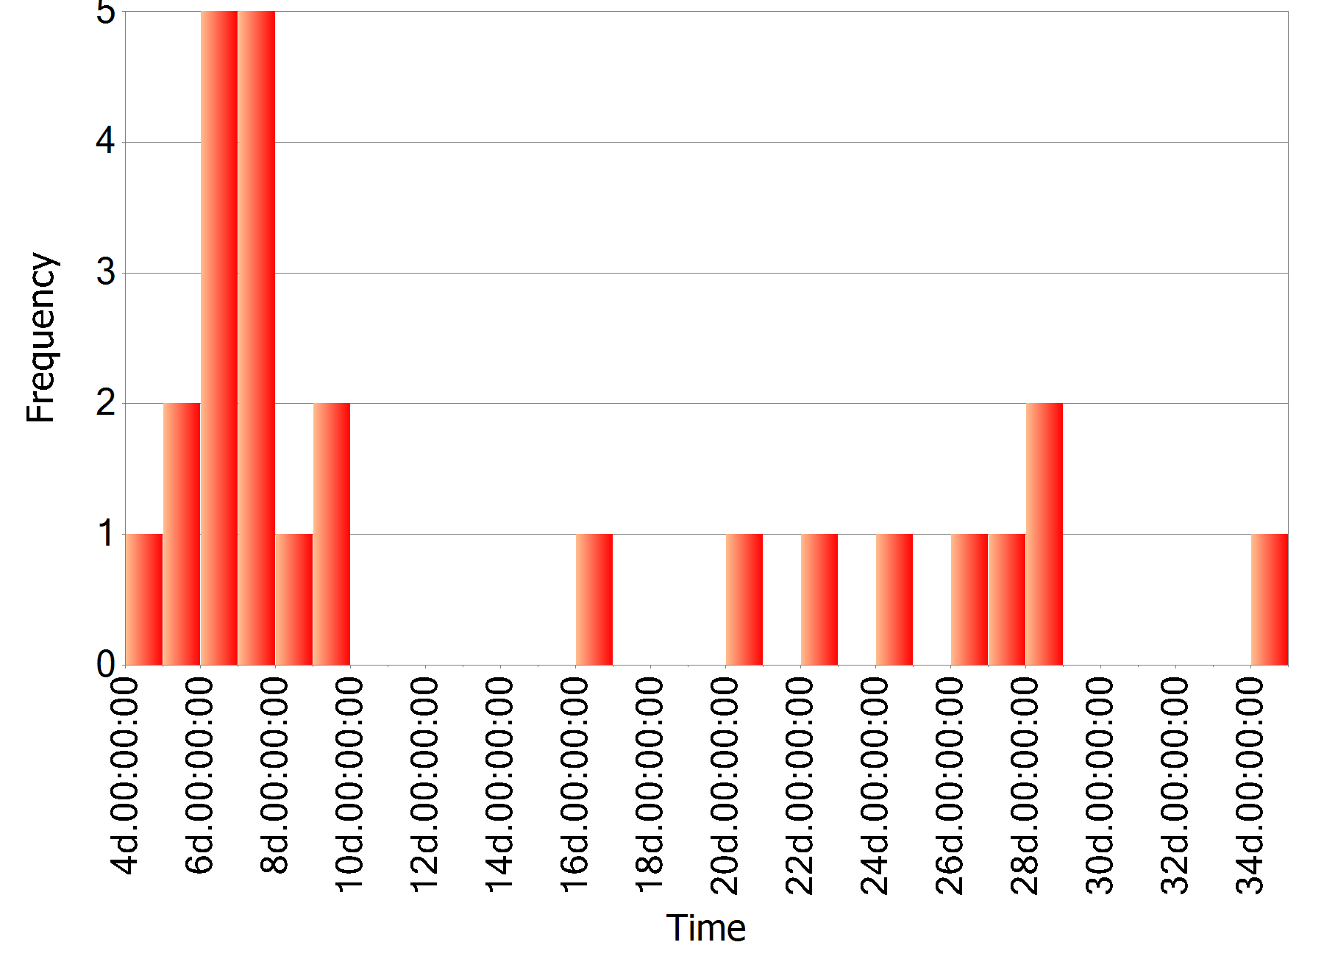

Process Instances Cost Distribution
